Public Debt and Economic Growth: A Global Comparison of Extremes
This project is done as part of my curiosity and academic needs.
Objective: The objective of this project is to conduct a global comparison of extremes regarding Public Debt and Economic Growth.
The overall aim is to investigate the relationship between these two key economic variables by collecting and analyzing data from 49 countries across advanced, emerging and developing economies.
Key components of the objective –
- Variables of Focus: The analysis centers on two key measurements – Debt-to-GDP percent, GDP growth percent
- Data scope: To collect and clean data from 7 regional groupings of countries (including G7 NATIONS, EURO AREA and various other emerging economies)
- Initial findings: To identify the top 10 highest-debt countries based on the collected data.
- Motivation: The project is undertaken due to curiosity and academic needs.
Part 1: Data Collection
I have personally collected the data in 7 different excel files from the official Internal Monetary Fund’s (IMF) World Economic Outlook (WEO) database ( https://www.imf.org/en/publications/weo/weo-database/2024/october/select-country-group ).
As in the link given it is divided into 2:
- Advanced economies
- Emerging market and developing economies
The data collected was in 7 different headings with respective name of sections given under the headings of Advanced Economies and Emerging market and developing economies.
The 7 excel sheets are:
- WEO_Data (G7 NATIONS).xlsx
- WEO_Data (EURO AREA).xlsx
- WEO_Data (EMERGING ECONOMIES_SUB-SAHARAN AFRICA).xlsx
- WEO_Data (EMERGING ECONOMIES_MIDDLE EAST & CENTRAL ASIA).xlsx
- WEO_Data (EMERGING ECONOMIES_LATIN AMERICA & CARIBBEAN).xlsx
- WEO_Data (EMERGING ECONOMIES_EUROPE).xlsx
- WEO_Data (EMERGING ECONOMIES_ASIA).xlsx
Each of these excel sheets contain many different countries that were divided according to different regions of the world. These regions are given as headings for each of the excel files.
Part 2: Data cleaning
This part is involving around merging the 7 excel files and cleaning the data by removing duplicate entries.
Data cleaning was done through Pandas library in Python by using pd.concat( ) function to ensure complete, globally ranked list of counties.
The code used for merging files in Pandas library of Python is given below using my own github link: https://github.com/renjithvarma2k7-tech/Undergrad-Economics-Projects
After series of cleaning, the final file had 49 counties and the key measurements were debt to GDP percent and GDP growth percent.
By cleaning I came to a conclusion on:
The top 10 countries (Highest Debt to GDP) with region:

RANK | COUNTRY | REGION | DEBT TO GDP PERCENT
1 | France | G7 NATIONS | 118.6
2 | Germany | G7 NATIONS | 114.7
3 | Italy | G7 NATIONS | 110.0
4 | South Africa | EMERGING ECONOMIES SUB-SAHARAN AFRICA | 110.0
5 | Bulgaria | EMERGING ECONOMIES EUROPE | 101.0
6 | Ethiopia | EMERGING ECONOMIES SUB-SAHARAN AFRICA | 100.6
7 | Hungary | EMERGING ECONOMIES EUROPE | 99.0
8 | Malaysia | EMERGING ECONOMIES ASIA | 95.0
9 | Mexico | EMERGING ECONOMIES LATIN AMERICA & CARIBBEAN | 94.9
10 | Germany | EURO AREA | 94.5

The bottom 10 counties (Lowest Debt to GDP) with region:

RANK | COUNTRY | REGION | DEBT TO GDP PERCENT
1 | United Kingdom | G7 NATIONS | 30.1
2 | China | EMERGING ECONOMIES ASIA | 30.8
3 | Saudi Arabia | EMERGING ECONOMIES MIDDLE EAST & CENTRAL ASIA | 36.5
4 | Philippines | EMERGING ECONOMIES ASIA | 37.5
5 | Netherlands | EURO AREA | 38.7
6 | Uganda | EMERGING ECONOMIES SUB-SAHARAN AFRICA | 40.0
7 | Israel | EMERGING ECONOMIES MIDDLE EAST & CENTRAL ASIA | 41.6
8 | France | EURO AREA | 41.7
9 | United States | G7 NATIONS | 46.9
10 | Kazakhstan | EMERGING ECONOMIES MIDDLE EAST & CENTRAL ASIA | 47.0

After reviewing Top 10 highest debt to GDP countries, we can see that certain countries like Germany were entered twice causing duplication. The main cause of such an entry is because the excel files were divided into 7 based on their respected regions. For the final analysis, a consistent rule was applied: The country – specific entry from the most granular files (e.g., G7 NATIONS or individual country data) was retained and the broader regional aggregate entry (e.g., EURO AREA) was discarded. This ensures that the final files had 49 unique country entries, each represented by a single, country-level data point.
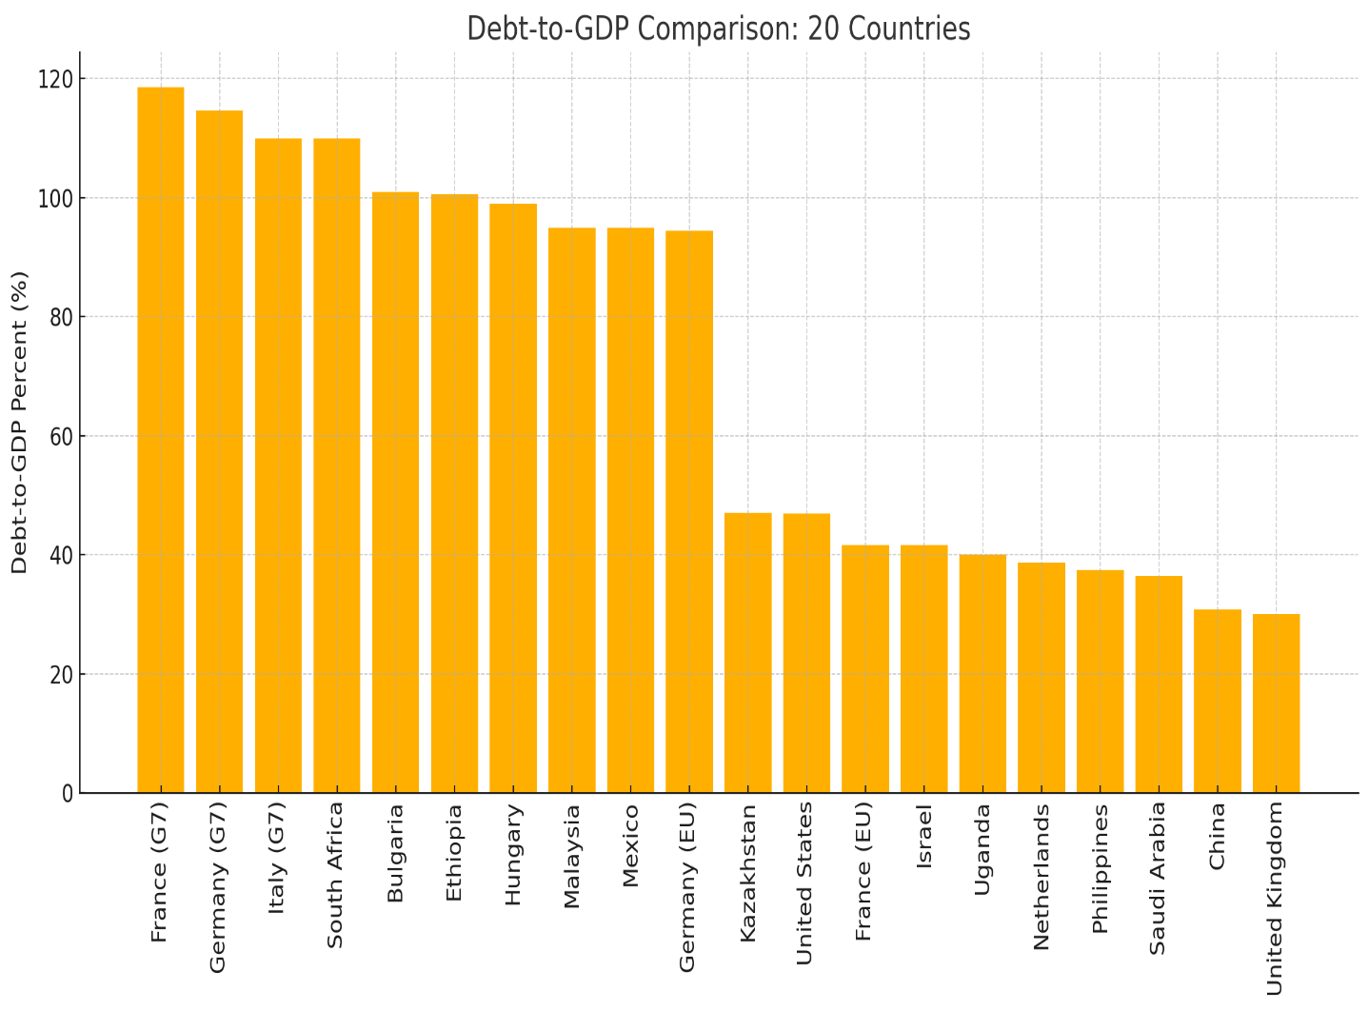
This visualization directly addresses the project’s objective of conducting a “Global Comparison of Extremes” by contrasting countries with highest public debt against those with lowest public debt as a percentage of their Gross Domestic Product (GDP). The chart represents the Debt-to-GDP percent for the top 10 highest-debt and the 10 lowest-debt countries identified from initial cleaning of the 49-country dataset.

Part 3: Summary Statistics
In this part we will see how the variables (debt-to-GDP percents and GDP growth percent) are related in this project and the results of my project.
First, we will create a summary statistics table:
Statistic | Debt-to-GDP percent (%) | GDP Growth Percent (%)
Mean | 73.36 | 2.99
Median | 77.40 | 3.33
Standard Deviation | 23.67 | 2.75
Minimum | 30.10 | -1.81
Maximum | 118.60 | 7.53

Explanatory Data Analysis (EDA) – Summary Statistics
The initial phase of the EDA involves around calculating descriptive statistics for the two core variables across the final 49 countries: Debt-to-GDP Percent and GDP Growth Percent.
Debt-to-GDP Percent: The average public debt burden across the global sample is 73.36%. This average is higher than the middle values, or median of 77.40%, suggesting that the overall debt data is slightly distorted by a few high-debt outliners (which were visualized in the previous section). The large standard deviation of 23.67% confirms the significant spread, ranging from a minimum of 30.10% to a maximum of 118.60%.
GDP Growth Percent: For economic outcome variable, the average GDP growth rate is 2.99% with a median of 3.33%. The standard deviation of 2.75% indicates that while most countries are clustered near the average, there are notable differences in economic performance, ranging from a minimum growth rate of -1.81% to a very strong maximum growth rate of 7.53%.

Part 4: Visual Relationship Analysis:

The core objective of this project-to investigate the relationship between public debt and economic growth-is visually addressed by the scatter plot given above. The plot displays the Debt-to-GDP percent (%) on the x-axis against the GDP Growth Percent (%) on the y-axis for all 49 countries in the sample.
Interpretation od Debt and Growth Relationship
- Direction (Negative Trend): The trendline slopes slightly downward, indicating a weak and negative relationship. Generally, countries with higher public debt tend to be associated with slightly lower GDP growth rates.
- Strength (Weak Correlation): The data points are widely scattered around the trendline, showing that the correlation is weak. This confirms that the debt-to-GDP ratio is only one of many factors influencing a county’s growth.
- Outliners: The presence of many countries far from the line (outliers) highlights that factor other than debt-such as specific policy reforms, commodity prices or regional instability-are often more influential in determining a country’s economic growth rate.

Conclusion
This project successfully fulfilled its objective: to conduct a Global Comparison of Extremes regarding public debt and to visually investigate the relationship between the Debt-to-GDP Percent and GDP Growth Percent across a 49-country sample.

Summary of Findings

- Debt Extremes Confirmed (Part 2): The analysis of initial findings established a vast range in fiscal health across the global sample. The Debt-to-GDP ratios ranged from a low of $30.1\%$ to a high of $118.6\%$. This significant dispersion confirms the presence of "extremes" and validates the project's focus on comparative analysis.

- Weak Negative Relationship (Part 4): The Scatter Plot and its associated Trendline revealed a weak negative relationship between public debt and economic growth. While the trend suggests that higher debt is generally associated with slightly slower growth (a slope of approximately $-0.015$), the wide scattering of data points indicates that debt alone is not the primary determinant of a country's economic performance.

- Importance of Other Factors: The visual analysis clearly showed that many countries defy the general trend. For instance, some countries with low debt still experience very low growth, while some high-debt countries maintain strong growth. This highlights the crucial role played by other economic, political, and institutional factors that were not included in this simple model.

Limitations of this project
As an introductory exploratory analysis, this project has two primary limitations:
- Correlation vs. Causation: The analysis only established a correlation (an association) between the two variables. It does not prove causation; we cannot definitively state that high public debt causes low economic growth.

- Simple Model: The analysis used a simple, one-variable model. Real-world GDP growth is driven by many factors (e.g., inflation, investment, interest rates, trade policy).

In conclusion, the project provides strong visual evidence of the high heterogeneity in global debt burdens and confirms a mild negative association between debt and growth, opening the door for more complex econometric studies.

